# Assignment Briefing Sheet (2020/21 Academic Year)

## 1.0 Section A: Assignment title, important dates and weighting 6ELE00671

|  |  |  |  |
| --- | --- | --- | --- |
| Assignment title: | Face Recognition | Group or individual: | Individual |

|  |  |  |  |
| --- | --- | --- | --- |
| Module title: | Data Security and Biometrics | Module code: | 6ENT1031 |

|  |  |  |  |
| --- | --- | --- | --- |
| Module leader: | Dr Sooda Ramalingam | Moderator’s initials: | LM |

|  |  |  |  |
| --- | --- | --- | --- |
| **Submission deadline:** | Group1: 21/04/21, 7PM  Group2: 05/05/21, 7PM | Target date for return of marked assignment: | Group1: 10/05/21  Group2: 05/10/21 |

|  |  |  |
| --- | --- | --- |
| You are expected to spend about | 10 | Hours for this lab to complete this assignment to a satisfactory standard. |

|  |  |  |
| --- | --- | --- |
| This assignment is worth | **30%** | Of the overall assessment for this module. |

## Section B: Student(s) to complete

|  |  |
| --- | --- |
| **Student ID number** | **Year Code** |
| 18006731 | **Level 6** |

**Face Recognition**

This is an interaction of distinguishing or checking an individual through their face by catching, breaking down and contrasting facial examples. In this report we will take a gander at various work organizes that are completed during face acknowledgment to perform information catch and ID assignments. This works by identifying whether the picture is there then does check whereby the framework confirms the character of the picture by coordinating with it with a particular picture in the framework. In the ID cycle, the framework predicts the character by deciding the picture introduced in the event that it possibly coordinates with the ones put away in the framework.

**Verification**

Framework checks with the individual's pictures they guarantee to be. A match of low edge can result to a False certain consequently empowering unapproved individual mistakenly. A high match edge can conceivably result to a bogus contrary, implying that an individual will be unable to check their personality.

In this case the system compare one of the individual’s presented image and turn it into a template against all of the same individual saved template in the system.



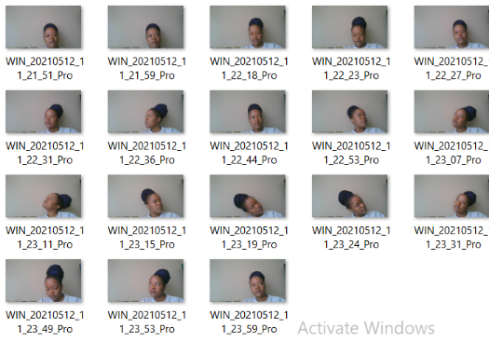

At this point the system check whether the physical camera captured face characteristics meets the captured ones.

IDENTIFICATION

Frameworks use PC calculations to choose explicit, unmistakable insights concerning an individual's face. These subtleties, like distance between the eyes or state of the jawline, are then changed over into a numerical portrayal and contrasted with information on different countenances gathered in a face acknowledgment data set.

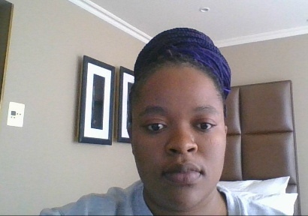

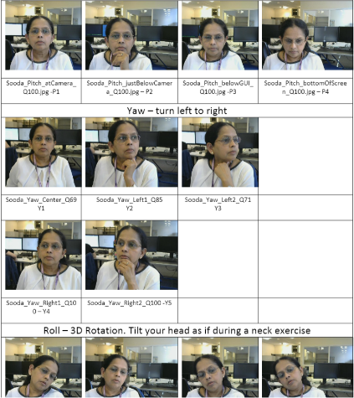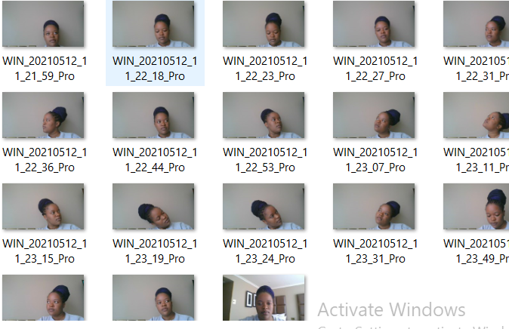

**Face Recognition Procedures**

**Highlight Extraction**

This is the place where a face is removed to give data that will be utilized to separate between faces. There are worldwide highlights which are factual characteristics of a picture's lattice that are obtained as surface highlights. When separating highlights there are a few factors that you need to consider. These elements may incorporate what data how it ought to be led, how it tends to be addressed also as how it very well may be utilized for investigation and comprehension.

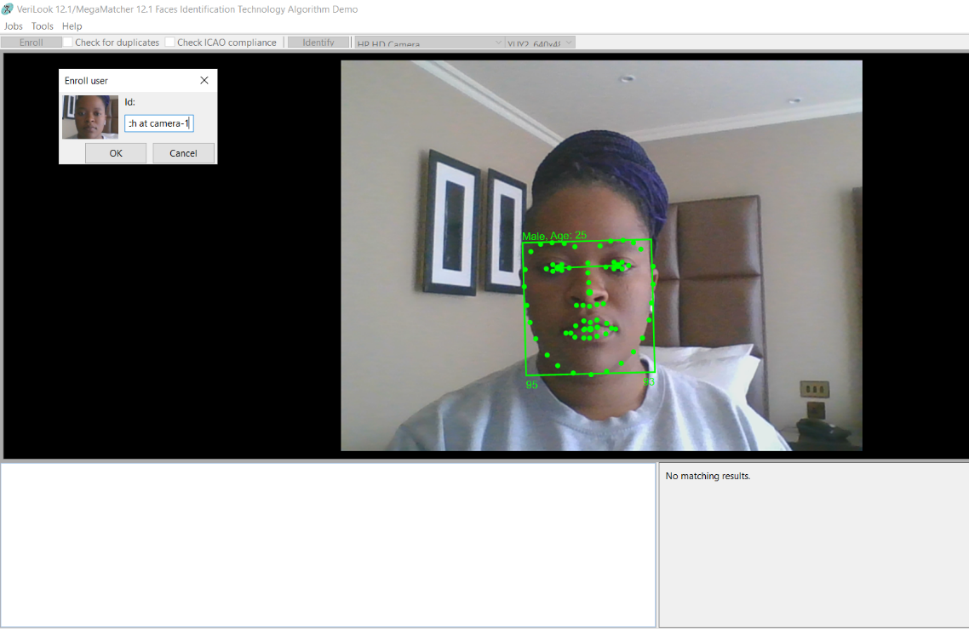

Figure 1.1 turning a picture into a template capturing

And the system is built in a way that it refuses to save 2 same template as shown in the image below

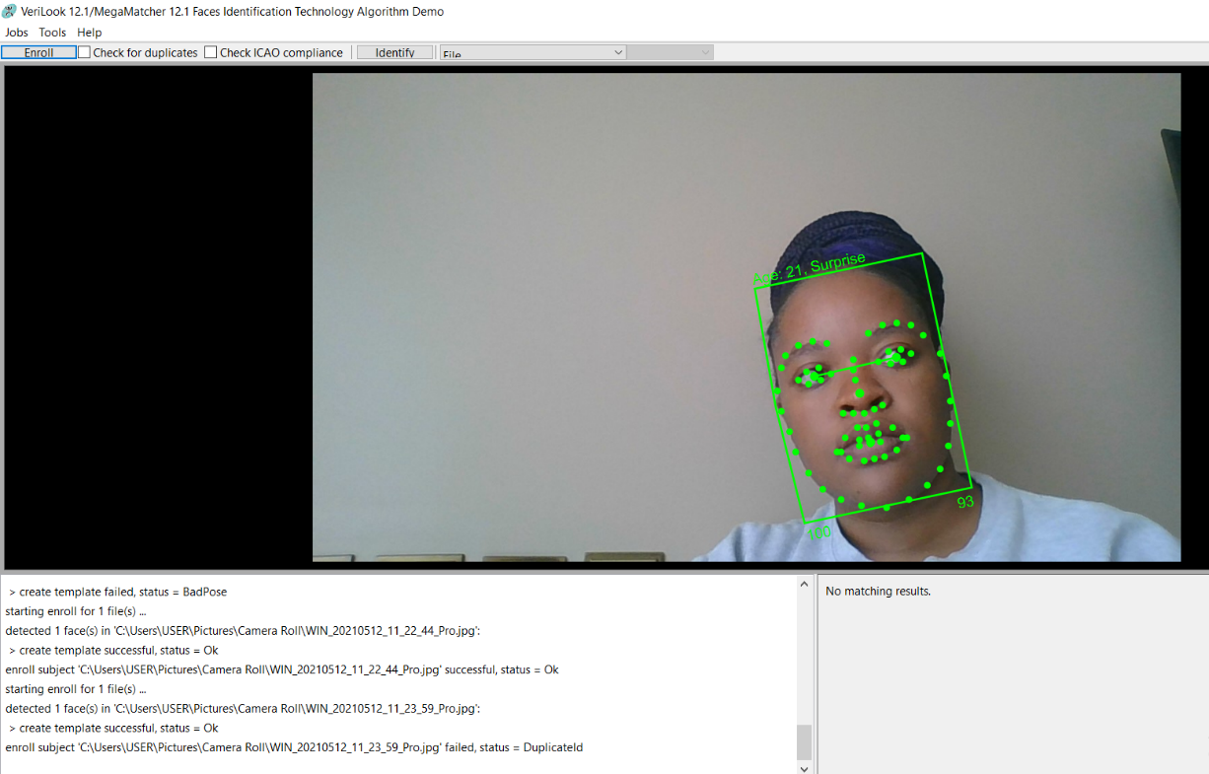

**Face acknowledgment Challenges**

Because of 3D construction of facial acknowledgment, there are a few picture varieties for a similar individual accordingly making face acknowledgment troublesome. With face acknowledgment it is troublesome between indistinguishable twins. There is additionally a constraint with regards to troublesome easing up conditions and along these lines it is less exact on dark surfaces.

**Picture Classification**

This is the way toward marking objects in the picture and arranging them in classes. In face identification, there are two classes whereby they decide either whether there is a face or no. Face acknowledgment is a multi-class and coordinating is performed against a few pictures in a data set framework to decide the ideal match

**Distance measures in grouping**

This is the distinction of inaccessible measures between at least two pictures. It offers a benefit of distinction. You can recognize of two pictures match when the distinction somewhere far off is negligible. Distance is gauges in w.r.t centroids. Each bunch has a centroid. In inside class distance, the focuses identify with the distance among them and contain a similar centroid though in the middle class the distance identifies with a specific point and the centroid.

To have a decent grouping, the inside distance ought to be negligible and the between distance ought to be most extreme.

**Distance Calculation**

As we have found in grouping, more modest the distinction the better the level of match. In distance estimation the distinction in distance is performed by coordinating with the RGB shading parts and by adding the distinctions. The most extreme worth in contrast is the best match. After the distance is determined, you can make a table where you rank the distance determined dependent on the distinction.

**Validation**

This is a test to determine how well the machine can validate a presented face information turned into template and link it to the information stored in database.

In a validation testing we have done a **one to one template matching** where the machine take one template and compares it to each template stored in a machine to match it with the one with highest score. As shown in the image below

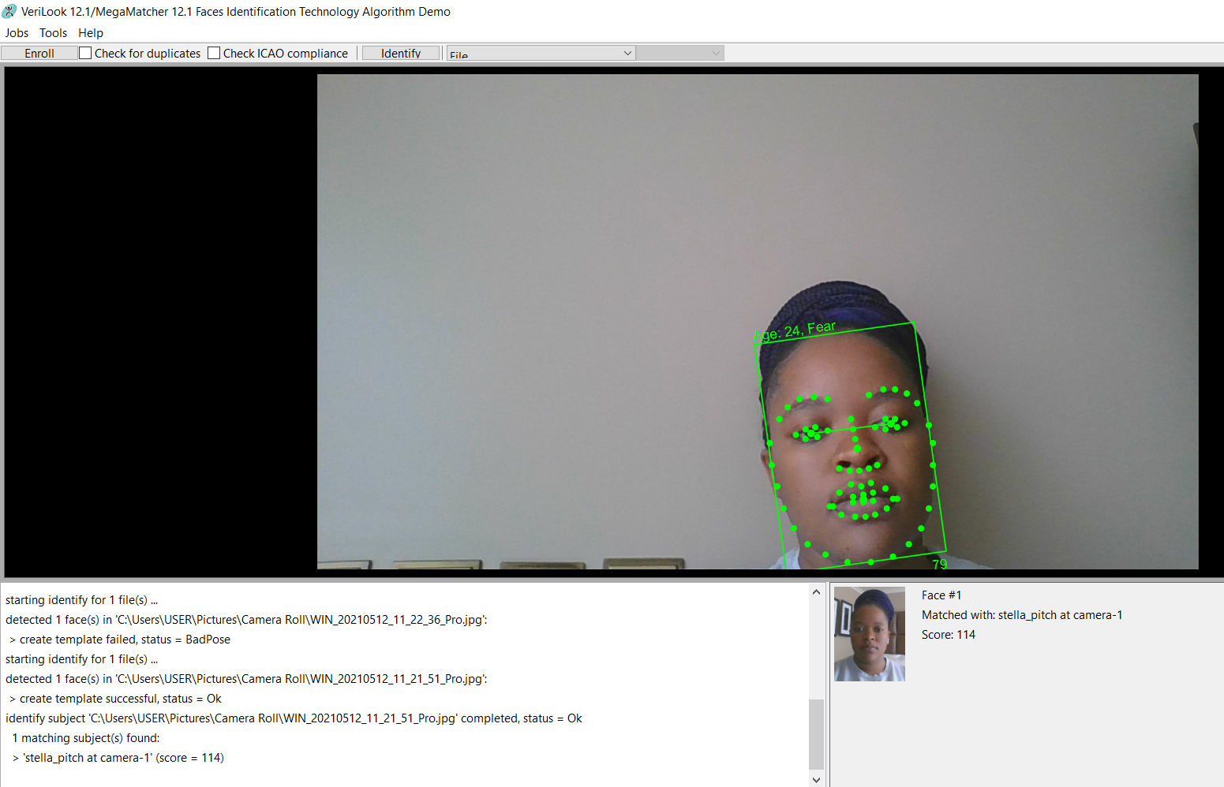

Figure 1.2 one to one matching

The following table shows the results from a one to one matching

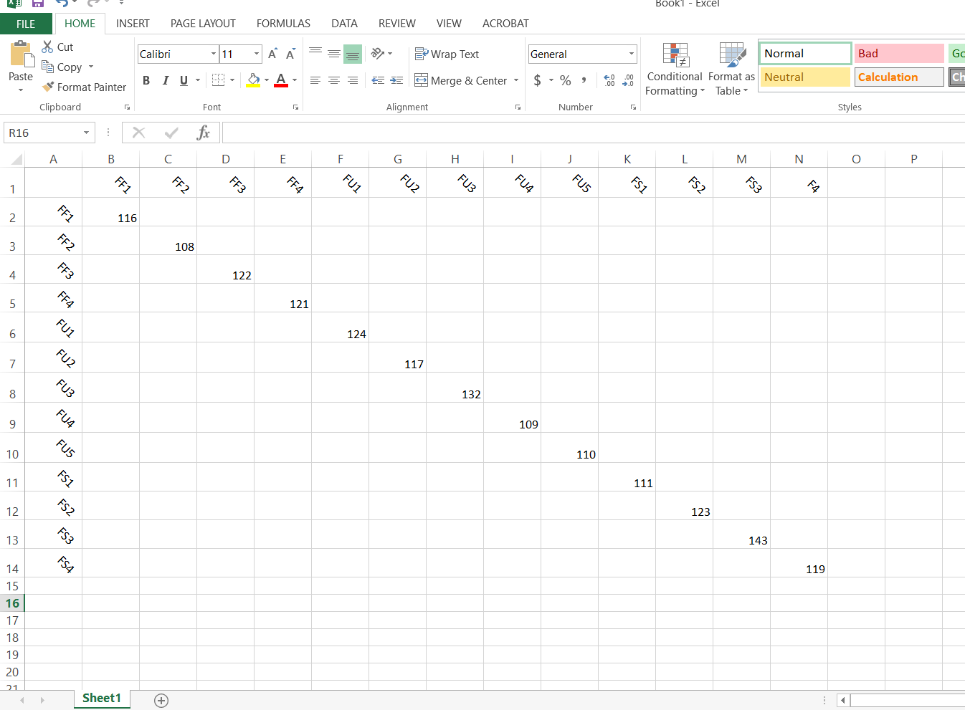

And then comes **One to many template matching** where a newly captured template is matched with all the stored template to extract the templates with the highest matching score among others. In this process the templates with the highest score signifies the best match. As shown on the screenshot below.

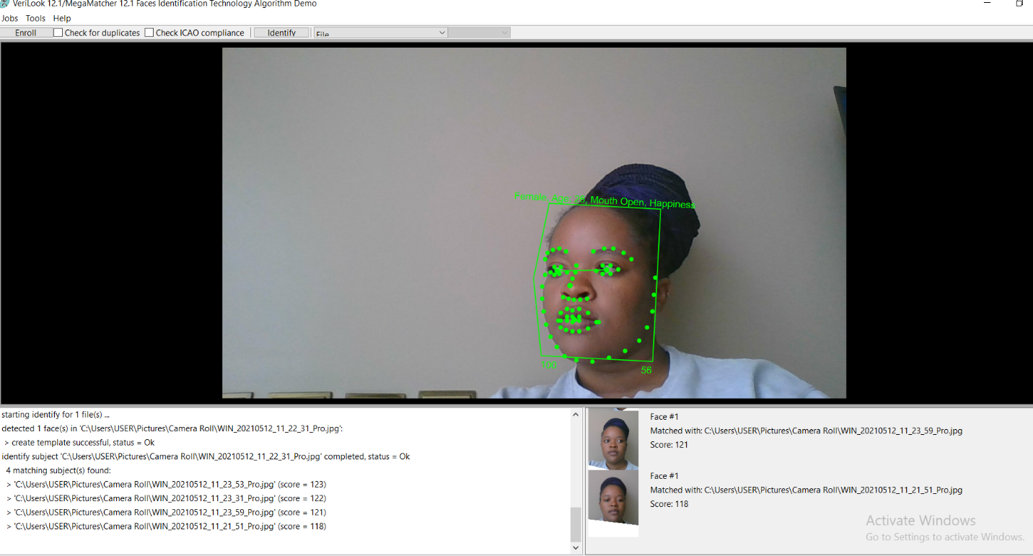

Figure 4 one to many matching template

Below is the one to many table comparison result

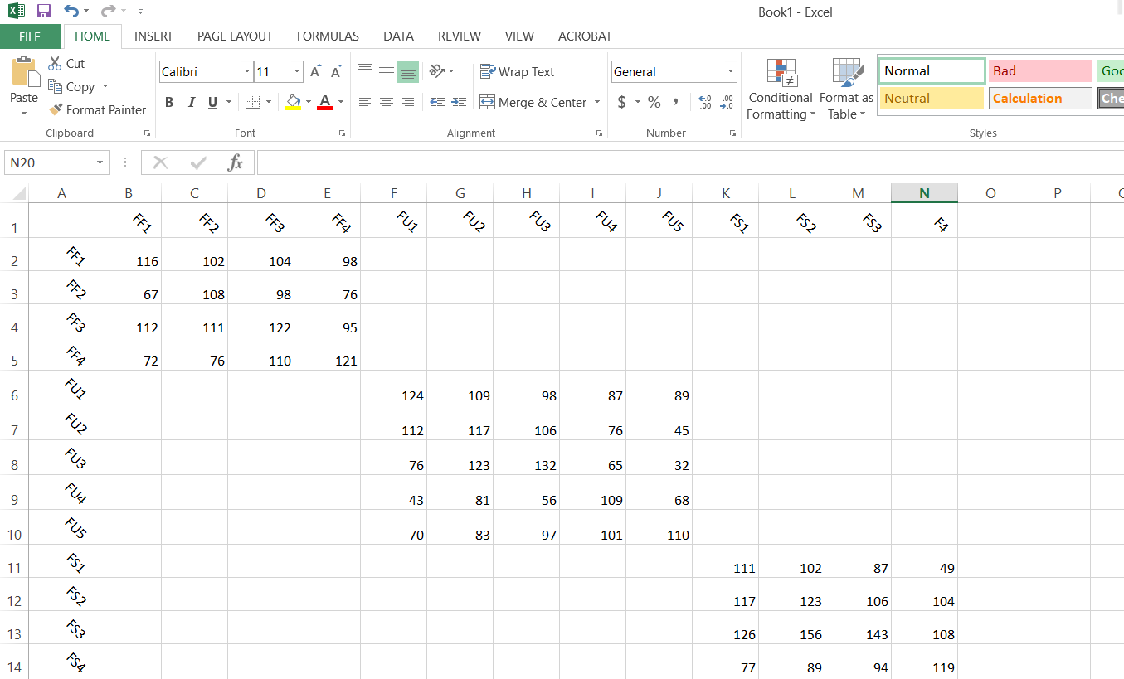

**Confusion Matrix**

This gives us a general proportion of execution of the framework dependent on the data set and the trial of picture blend. The highlights of the information base are addressed along one pivot and those of the test picture are addressed on another hub. When there is a match, components of these grid will contain right around zero qualities which shows that there is zero distance between them. The askew components are zero.

|  |  |  |
| --- | --- | --- |
|  | SOODA | STELLA |
| SOODA | 0.95 | 0.1 |
| STELLA | 0.2 | 0.98 |

**Performance Analysis**

There are a few measurements that can be utilized to assess the presentation, for example, Genuine Acceptance Rate (GAR), False Acceptance Rate (FAR), False Rejection rate (FRR). The presentation of a solitary calculation can change across datasets.

**FAR or False Acceptance Rate** is outlined because the proportion on that unauthorized person is incorrectly accepted within the system.

|  |  |  |
| --- | --- | --- |
|  | SOODA | STELLA |
| SOODA |  | 0.6 |
| STELLA | 0.4 |  |

**FRR or False Rejection Rate** is outlined because the proportion on that authorized person is incorrectly rejected into the system.

|  |  |  |
| --- | --- | --- |
|  | SOODA | STELLA |
| SOODA | 0.12 |  |
| STELLA |  | 0.02 |

It can be described in the image below

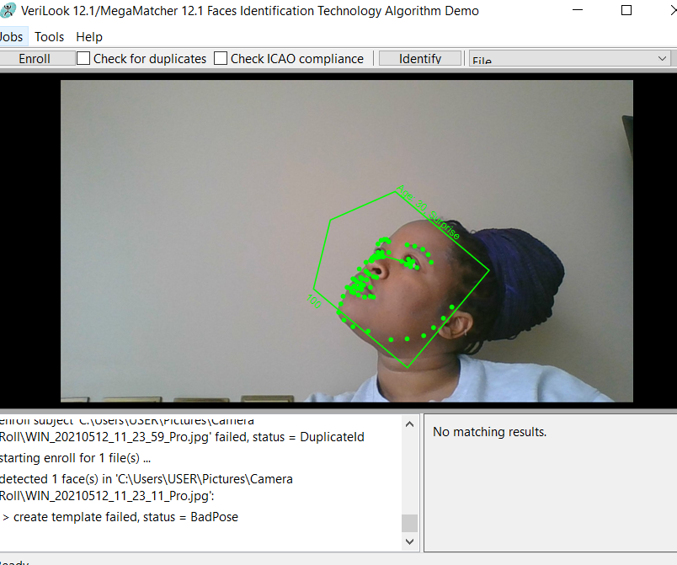

**True Acceptance Rate** is when the system gives access to the right person.

**True Rejection Rate** The rate to which the system deny the right person into the system.

**Conclusion**

This report concentrates on the validation testing on face recognition scanner. Considering the severity of the security of the system the world of technology still have more work to minimize both the FAR and FRR in order to avoid data theft and mishandling and also considering the theory of the of the validation testing it is a good method of testing on a big database as it can take give accurate results compared to generalization testing.

**References**

1. Thales Group. 2021. *Biometrics: definition, use cases and latest news*. [online] Available at: <http://www.thalesgroup.com/en/markets/digital-identity-and-security/government/inspired/biometrics> [Accessed 18 April 2021].
2. id3 Technologies. 2021. *Biometric Enrolment - Enroll fingerprints in your identification system | id3*. [online] Available at: <https://id3.eu/biometric-enrolment/> [Accessed 28 April 2021].
3. BV, AGN Business Internet. “FAR and FRR: Security Level versus User Convenience.” *Gebruikersvriendelijke Biometrische Beveiliging Van Hoge Kwaliteit*, www.recogtech.com/en/knowledge-base/security-level-versus-user-convenience.
4. Bayometric. 2021. *False Acceptance Rate (FAR) and False Recognition Rate (FRR)*. [online] Available at: <https://www.bayometric.com/false-acceptance-rate-far-false-recognition-rate-frr/> [Accessed 28 April 2021].
5. <https://journals.plos.org/plosone/article?id=10.1371/journal.pone.0242269>
6. <https://www.partnershiponai.org/wp-content/uploads/2020/02/Understanding-Facial-Recognition-Paper_final.pdf>
7. Web.stanford.edu. 2021. [online] Available at: <https://web.stanford.edu/class/ee368/Project_03/Project/reports/ee368group04.pdf> [Accessed 28 April 2021].
8. Partnershiponai.org. 2021. [online] Available at: <https://www.partnershiponai.org/wp-content/uploads/2020/02/Understanding-Facial-Recognition-Paper_final.pdf> [Accessed 28 April 2021].

**Appendix**

|  |  |  |  |  |  |
| --- | --- | --- | --- | --- | --- |
|  | **Can I use your image for the next academic purpose** | **Can I use your template for the next academic purpose** | Can I use your images for research purposes? | Can I use your templates for research purposes? | Can I publish any results that reveals your images? |
| Fingerprint | NO | NO | NO | NO | NO |
| Face Recognition | NO | NO | NO | NO | NO |